**Final Project name: Interview Registration system**

**Team members**: Hishaam Ahamad, Joseph Mackie, Bharath Palanisamy, Borjana Veliu

**Abstract**- The interview reservation system will allow companies and candidates to agree upon an interview date and time. The technology will enable candidates and the organization to communicate availability. The candidate can then select the time for the interview after receiving proposed dates and times from a scheduling provider.Users can view appointments in their calendars by integrating the system with Google Calendar or another calendaring tool. Anyone can interact with the system to identify and suggest a different date or time if they need to change the appointment's planned time or date. Both parties have the right to cancel interviews, and they are free to give a reason. The system will send notifications through email. Additionally, reporting will be given so that parties can have a complete picture of their interviews.

**Objectives**: Interview Request, Interview Confirmation, communications, company, candidate, scheduling, calendar integration, alerting, change (cancel/change date), reporting, and authentication and authorization

**Schedule**:

setting up Kubernetes - 7/18

setting up docker hub - 7/18

GitHub actions basic pipeline - 7/19

general architecture - 7/20

setup Kafka - 7/21

security - 7/23

communications - doing

Gatekeeper - 7/23

candidate - 7/29

scheduling doing

calendar integration - doing

Powerpoint - 8/2

Availability - 8/2

testing - 8/2

report – 8/3

**Technologies Used:**

* Web Development
  + Language: Python
  + Web Framework: Flask
  + Authentication Mechanism: JWT Token
* Data Development
  + ORM: SQLAlchemy
  + Database: Postgresql
  + Service Integration: Kafka
* DevOps
  + Container Creation: Docker
  + Container Registry: DockerHub
  + Service Orchestration: Kubernetes
  + Cloud Platform: Okteto
  + Source Control: Git
  + Source Control Repository: Github
  + Build and Deployment Tool: Github Actions

**Part 2: Process Flows**

Here is the GitHub link where the process flows for our project.

<https://github.com/hishaam19/CSC5991/blob/main/Documentation/ProcessFlows.pdf>

**Part 3: Project Outcomes**

Allowing companies and candidates to agree upon an interview.

Allowing the company and candidates to share their availability.

Allowing integration with Google Calendar.

Canceling or editing an interview.

Reporting the interviews scheduled.

**Part 4: Screenshot of our outcomes**

**Part 5: Goals achieved and remaining goals:**

**Increasing Productivity:**

* **Improving processes to produce the best results possible given the inputs.**
* **Determine who has the bandwidth for this project by examining the present workflow and outstanding tasks.**
* **Establish due dates for each activity.**
* **Every Friday, check in to make sure the project is on schedule.**

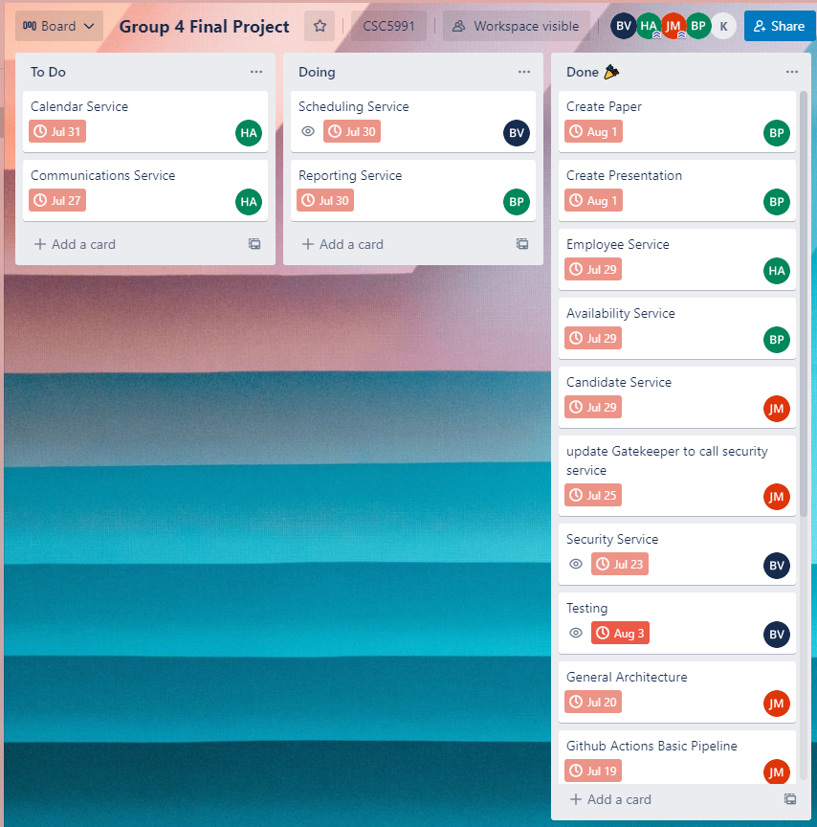

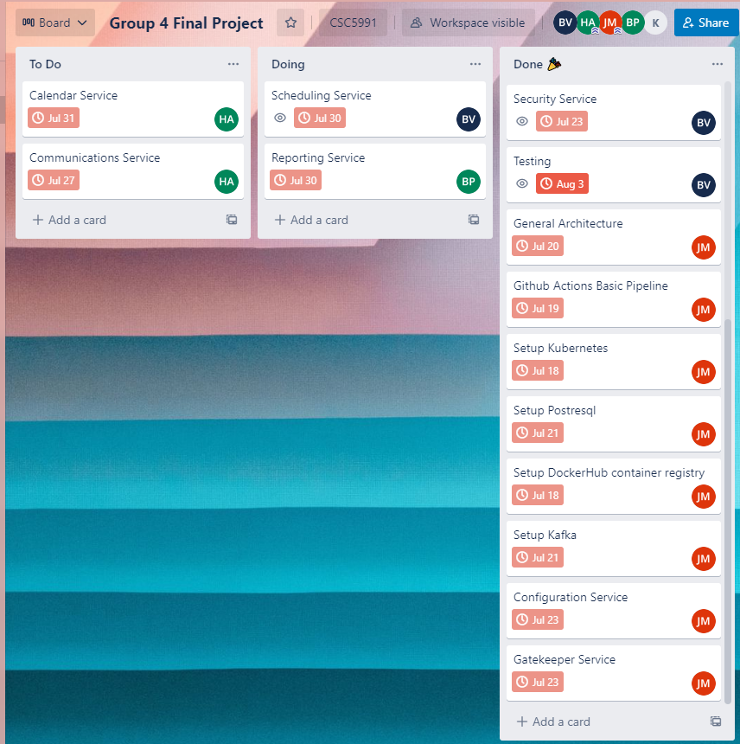

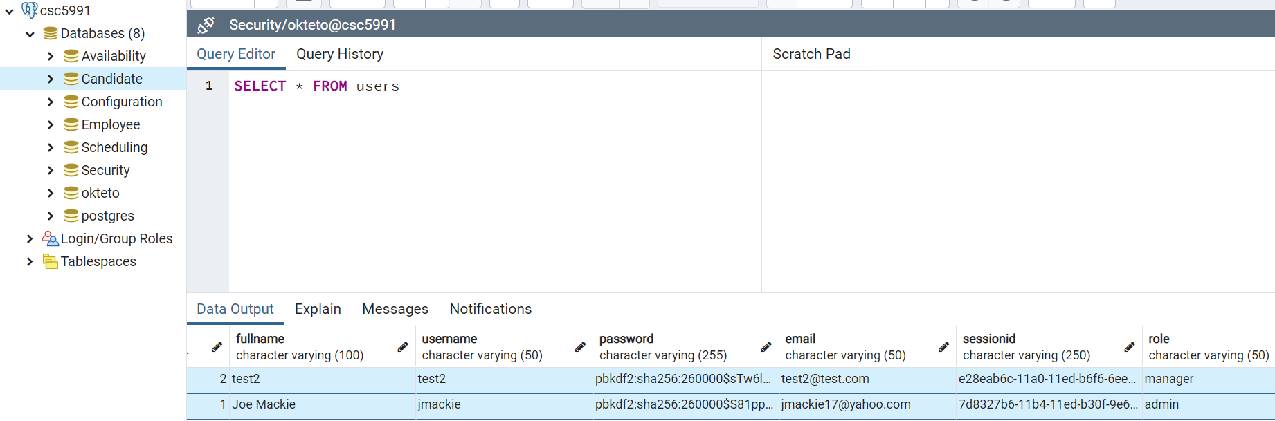

Implementing services like scheduling, employee, and availability service is one of our remaining goals. Due to difficulties in implementing those, we nevertheless provide these services. This was a big factor in our inability to merge the code in order to test its functionality on the cloud of oketeo. The targets we've already accomplished include putting up PostgreSQL, Kafka, Kubernetes, Oketo, and DockerHub. Thus, the objectives we established were justifiable.

**Part 6: Team member contributions and roles**

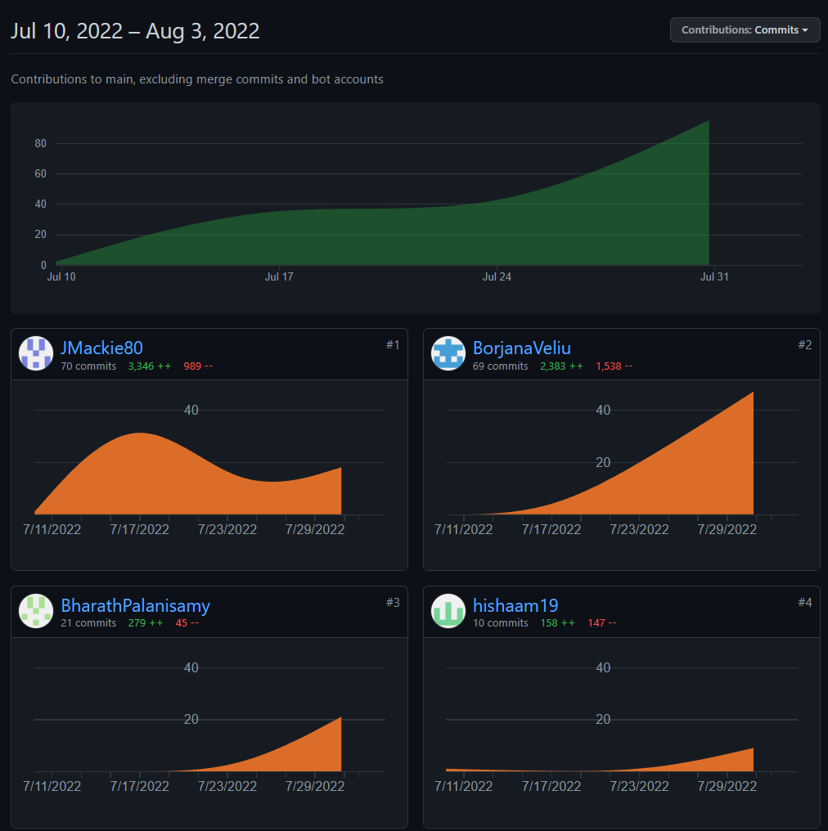

**Team Role:**

Joe - team lead, set up all the services, candidate service, configuration service, Process flows, network diagram, and powerpoint

Bharath - Reporting and Availability service, Paper, Powerpoint

Hishaam - Communication service, Employee service and Calendar service

Borjana - Scheduling service, Security Service (authentication and authorization), and Testing

Is all shown in the picture above. You can see what every single person did so far, as well as all the roles assigned to each person.

**Part 7: GitHub, Trello (or the agile tool we used), and container registry address**

[**https://trello.com/b/8ts8WKw6/group-4-final-project**](https://trello.com/b/8ts8WKw6/group-4-final-project)

[**https://kafka-ui-service-infrastructure-jmackie80.cloud.okteto.net/**](https://kafka-ui-service-infrastructure-jmackie80.cloud.okteto.net/)

[**https://pgadmin-infrastructure-jmackie80.cloud.okteto.net/**](https://pgadmin-infrastructure-jmackie80.cloud.okteto.net/)

**https://github.com/hishaam19/CSC5991**